Hallows Fall Fest 2026 · Media Kit
Krush Brau Park · Kissimmee, Florida · Saturday, October 24, 2026
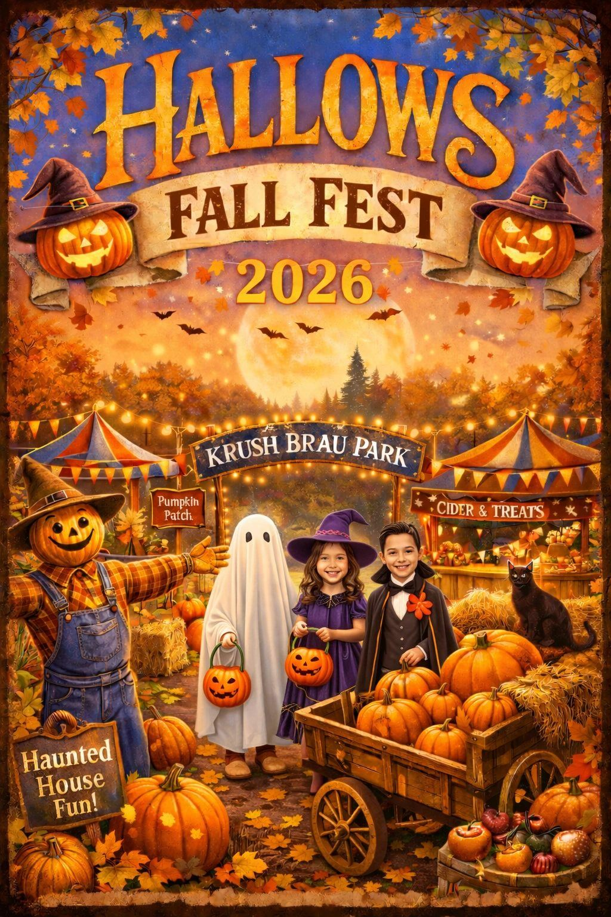

Event overview
Hallows Fall Fest brings costumes, a fall market, music, kids activities and the beer garden together for the whole family the weekend before Halloween. Free admission tickets are available; the haunted house and haunted escape room cost extra. All ages. Free on-site parking. Leashed dogs are welcome in outdoor areas.

At a glance
Date | Saturday, October 24, 2026
Hours | Noon – 9pm
Where | Krush Brau Park, 4580 W Irlo Bronson Memorial Hwy, Kissimmee, FL 34746 (event listings name the Portal Immersion Center, 2198 Four Winds Blvd, on the park property)
Admission | Free admission tickets on Eventbrite; haunted house and escape room extra
Tickets | eventbrite.com/e/1991125206091
Event page | krushbrau.com/events/hallows-fall-fest/
Media contact | contact@krushbraupark.com
Social | @krushbraupark (Instagram, TikTok)

Schedule
Gates noon to 9pm. Times for individual activities (costume contest judging, pumpkin decorating, etc.) have not been published yet; we will confirm them with approved media by email.

Experiences
- Costume contest for kids, pets and adults: Spookiest, Funniest and Most Creative, with prizes
- Pumpkin decorating
- Trick-or-treat trail with our vendors
- Music from a DJ
- Craft corner: autumn-themed arts and crafts
- Beer garden with seasonal brews and a German fall menu
- Fall vendor market
- Haunted house (additional cost)
- Haunted escape room (additional cost)

The park story
In 2020, U.S. Army veteran Waylon Krush and his wife, Kathryn Krush, bought a closed zoo on U.S. 192 in Kissimmee, the former Jungleland Zoo, to build a place for Oktoberfest year-round, with a garden like the beer garden in Munich. The property was first named Tiger König ("König" is German for "king"), and is now Krush Brau Park, the veteran-owned German beer garden next door to Medieval Times. The original lion and tiger cages from the zoo days still stand in the back of the park.

Photo and video guidance
- Photos and video for editorial and social coverage are welcome in public areas.
- Please ask before filming other guests up close, and get a parent's OK before featuring children (for example in the kids' costume contest).
- Ask us first about drones, live-streaming, lighting rigs or filming inside the haunted house or escape room (no escape-room spoilers, please).
- The haunted house has tight spaces, dark areas and loud sounds.
- Tag @krushbraupark and link krushbrau.com/events/hallows-fall-fest/.

How to request free tickets and experiences
Media outlets and influencers can request complimentary tickets and experiences at krushbrau.com/media/ or krushbraupark.com/media/, or by email to contact@krushbraupark.com. Please include:
- Outlet or channel name, and your name
- Email (and phone if you like)
- Audience size and links (follower counts per platform, circulation or monthly readers)
- Coverage plan: what you will create, where it runs, and when it publishes
- Which experiences you want (admission, haunted house, escape room, food/beer garden, interview)
- Party size and names
- Planned arrival time
Every request is reviewed and confirmed by email from contact@krushbraupark.com. Requests are not guaranteed, and nothing is confirmed until you get our written reply. Because the event is on October 24, please send requests as soon as possible.

Veterans
Discounted tickets for Krush Brau events are available to veterans through Vet Tix (vettix.org).

Boilerplate
Krush Brau Park is a veteran-owned German beer garden and event park on U.S. 192 in Kissimmee, Florida, built on the grounds of the former Jungleland Zoo. It hosts Oktoberfest, Hallows Fall Fest, Krampus Con and other festivals, brunches and concerts, plus private parties and events. krushbrau.com · contact@krushbraupark.com

